1. Install Jenkins server on local or remote machine

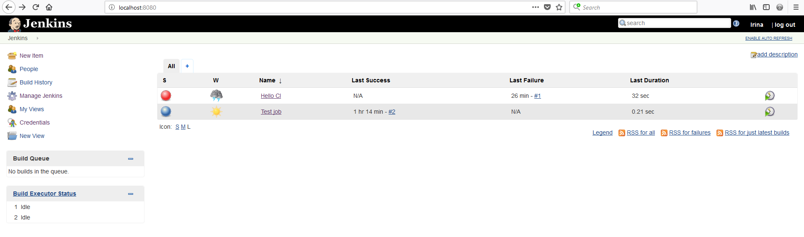

1. Create a job with the following steps:
   1. Get code from git repository: <https://github.com/vitalliuss/helloci>

Build and run unit tests from Java folder. Use “test” goal for maven

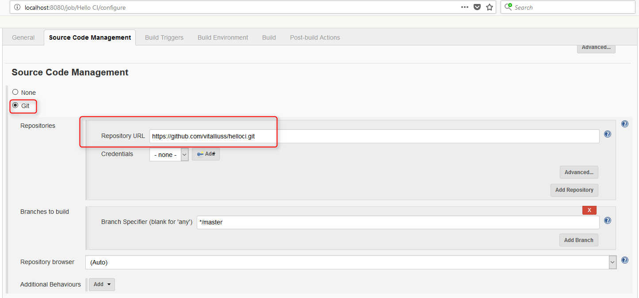

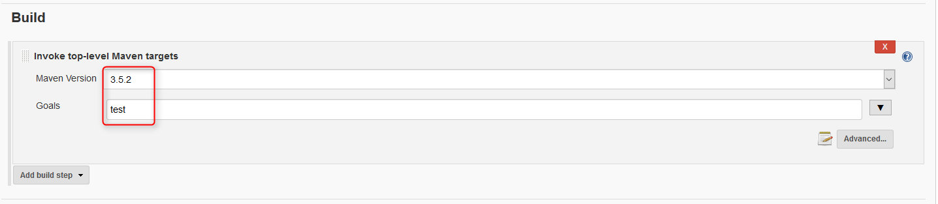

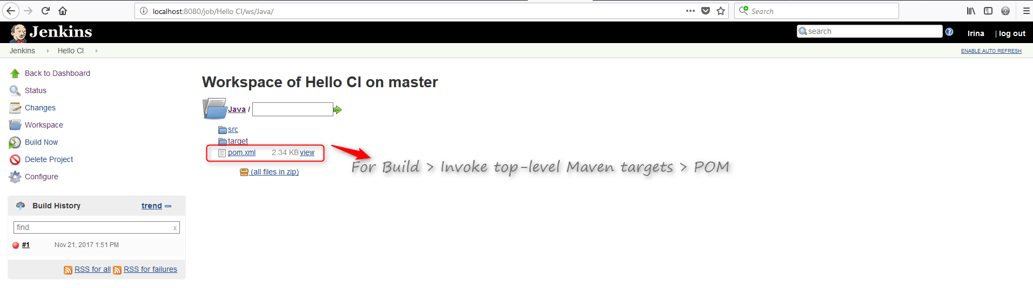

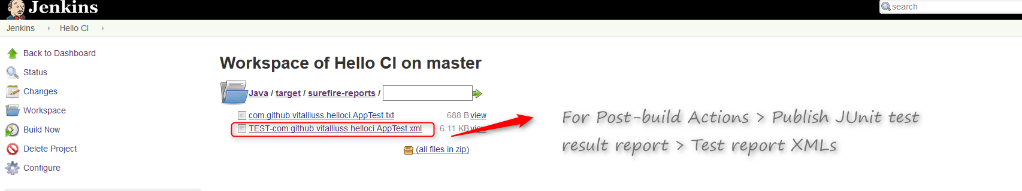

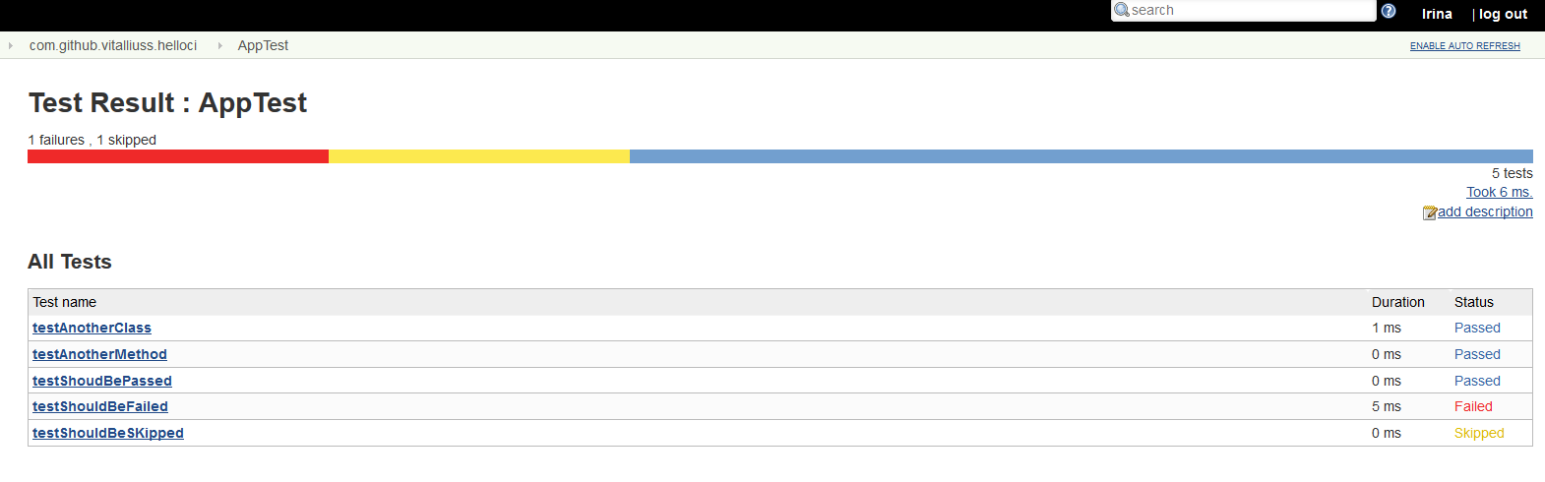

1. Set build triggers:

after commit in VCS

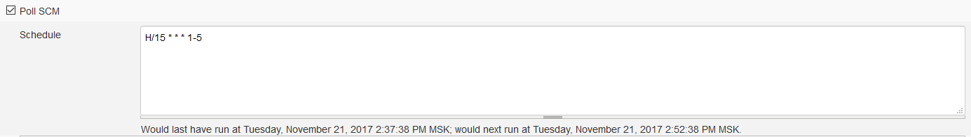

at midnight every weekday (Mon-Fri)

